Task 1 & 2

Data Sequence 1 was taken from [Click Here](https://www.ncbi.nlm.nih.gov/nuccore/NM_001302688.2?report=fasta) or <https://www.ncbi.nlm.nih.gov/nuccore/NM_001302688.2?report=fasta>

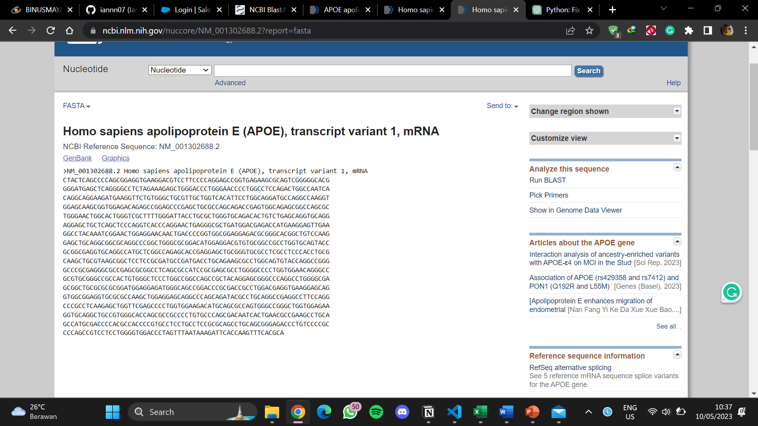

Data Sequence 2 was taken from [Click Here](https://www.ncbi.nlm.nih.gov/nuccore/NM_000041.4?report=fasta) or <https://www.ncbi.nlm.nih.gov/nuccore/NM_000041.4?report=fasta>

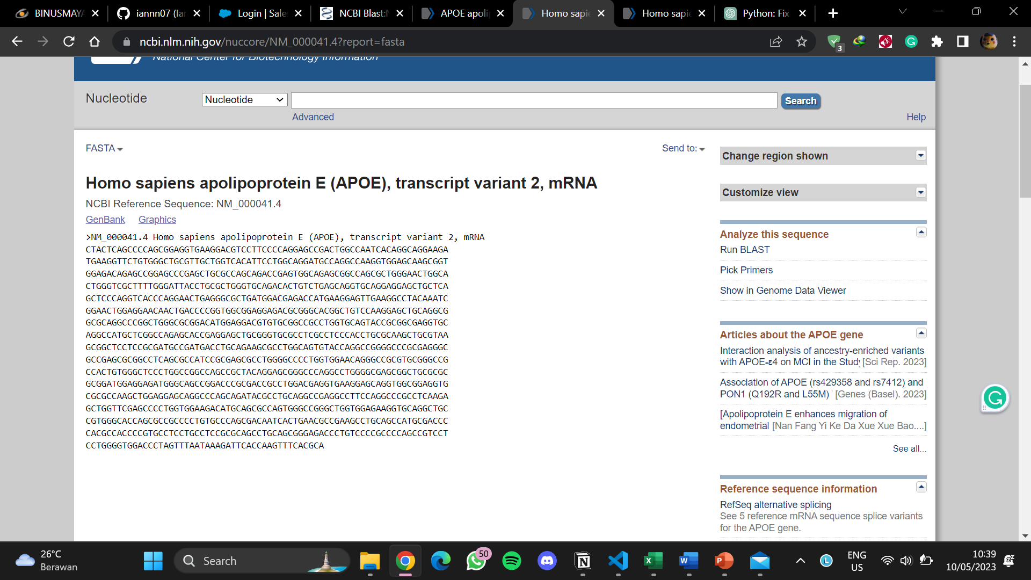

These sequences are the interpretation of Human Apolipoprotein E with different variances. This APOE is involved in the metabolism of fats in human for making a protein called apolipoprotein E which combines with fats in the body to form lipoprotein.

Task 3

This sequence can be found at: [Click Here](https://www.ncbi.nlm.nih.gov/gene/6331#gene-expression) or <https://www.ncbi.nlm.nih.gov/gene/6331#gene-expression>

This protein is found in cardiac muscle and used as the initial upstroke of the action in an electrocardiogram. This gene has defects in its findings which contain such as Atrial Fibrillation, Cardiomyopathy, and Brugada Syndrome 1. I took the Sequence Reference from transcript [variant 2](https://www.ncbi.nlm.nih.gov/nuccore/NM_000335.5?report=fasta), [variant 3](https://www.ncbi.nlm.nih.gov/nuccore/NM_001099404.2?report=fasta), [variant 4](https://www.ncbi.nlm.nih.gov/nuccore/NM_001099405.2?report=fasta).

Result

Google Colab Link: [Click Here](https://colab.research.google.com/drive/1bHldt-ufEXHFRC1wfmsZiTgWv4il7FSs?usp=sharing) or <https://colab.research.google.com/drive/1bHldt-ufEXHFRC1wfmsZiTgWv4il7FSs?usp=sharing>

Task 1

Task 2

Task 3

